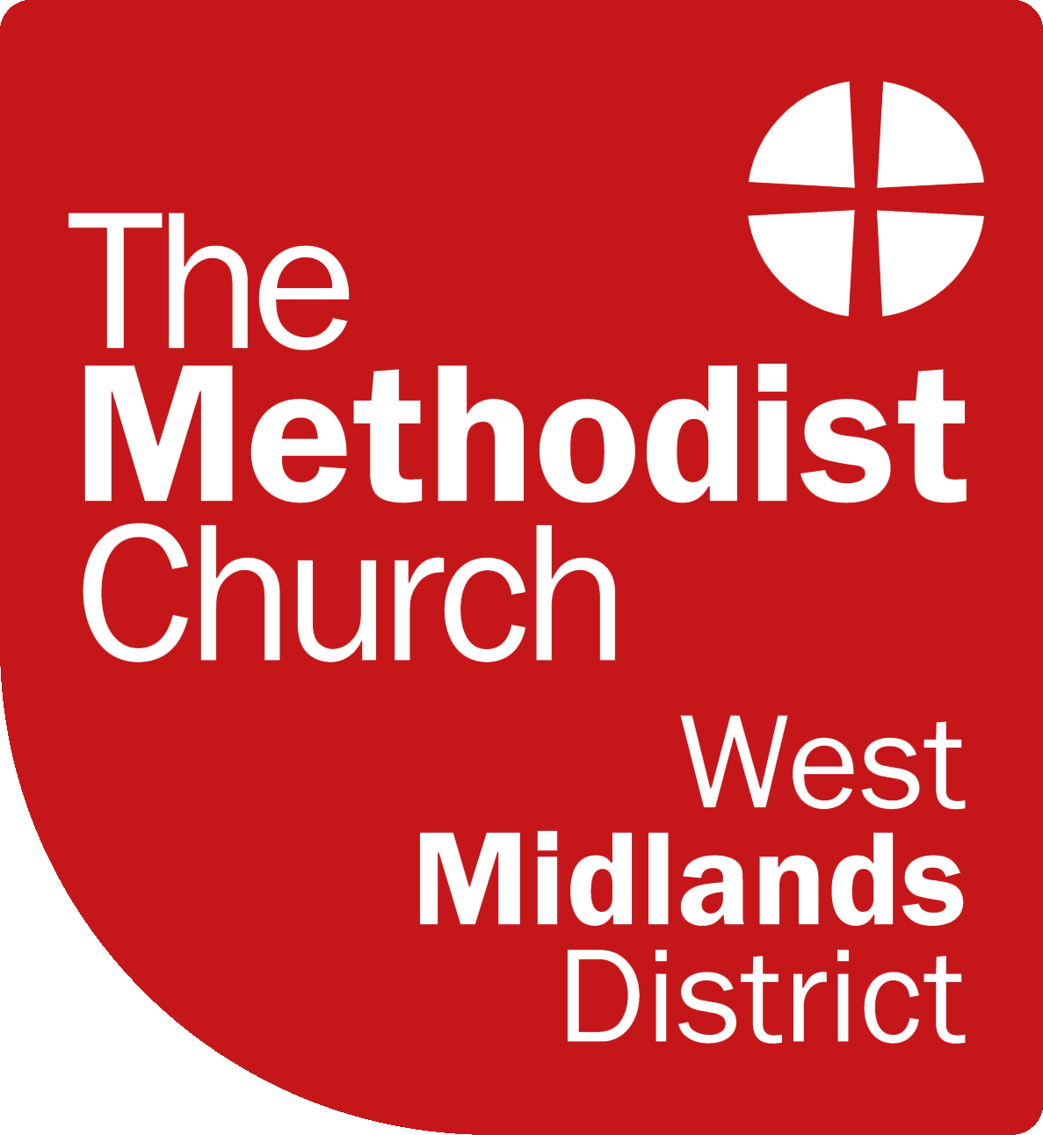
THE METHODIST CHURCH - WEST MIDLANDS DISTRICT

NOMINATION TO METHODIST CONFERENCE

METHODIST CONFERENCE 2026 - Telford

25th -26th June (Presbyteral Session),

27th June – 1st July (Representative Session)

Election of representatives from the West Midlands District

The West Midlands District will send a total of 12 representatives to the Methodist Conference as follows:-

six ministerial representatives, at least two of whom must be deacons, and six lay representatives. The Synod Secretary automatically has a place. Synod will be asked to agree that one lay and one ministerial representative will serve for 3 years.

We are seeking through our representatives to reflect the variety of the District and include those with experience and those who bring new perspectives.
The only qualification for nomination is membership of the Methodist Church.

Representatives will become members of Synod for the year leading up to, and that following, Conference and will therefore become more involved with district matters. There are facilities for loss of earnings to be compensated.

Please obtain permission from anyone you wish to nominate, or you may nominate yourself.

This Nomination Form must be returned to info@wmmethodists.org.uk by 25th August 2025.
Further copies of the form are available on the district website.

THE METHODIST CHURCH - WEST MIDLANDS DISTRICT

NOMINATION FOR CONFERENCE 2026

Name (including title)

Circuit

Address (inc. Postcode)

Tel. No

Email

Age group (please tick) under 30 30/40 40/50 50/60 over 60

Ethnic origin

Previous years attended conference

Are you prepared to serve for three years? Yes/no (please delete as necessary)

Why would you like to attend the Conference? (max 50 words)

What experience and new perspectives can you offer? (max 50 words)

Please return this form attaching a photograph to info@wmmethodists.org.uk by 25th August 2025.

